Brendan Clarke
CS 499
Module 5
Milestone 4

Python, using MongoDB is a really great way to build a simple web data visualization app, you can make your data dynamic to help with routine imports and ever expansive data points. In CS 340 I built a dashboard and a simple python script for CRUD tools. This was in the perspective of using dog rescues based on data from a CSV file. My intention on enhancing this project is to create new ways to visualize the data. Now since this class was from over 90 days ago I had trouble accessing the virtual desktop and that said the entire environment used for this class. Since we are going to just be working with the front end. I decided to avoid the MongoDB part and just use Dash, Plotly libraries with python to take the data directly from the original CSV file. This was after a few attempts of starting a MongoDB server on my personal desktop, which is technically straight forward, but since I have had previous databases running still, it gave way to issues and limited hardware scalability led me to use my old laptop running a linux distro Debian to run the MongoDB just for testing purposes while I messed with the GUI and tools in the original python file.
Which for additional context, this class was using jupyter notebook, which Microsoft visual studio code, does have a plugin for, I think for the sake of making this a more legitimate standalone project, I will fully convert every portion of this app to a single python file. And it is in this simplicity that I can work with all parts of the entire app to coordinate better visualization tools.
For context here is my current dashboard,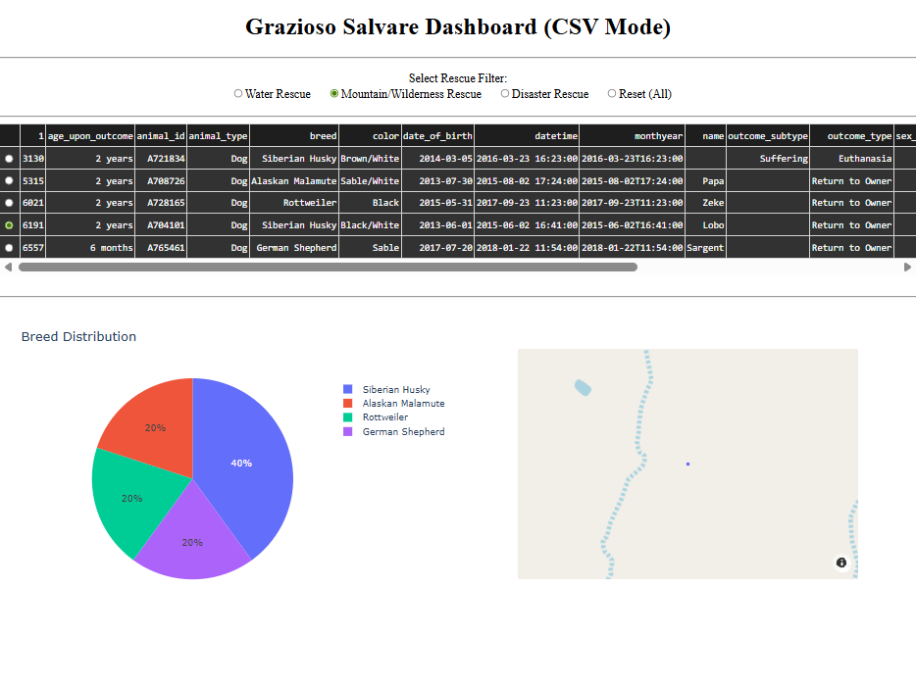
This is a great way to quickly understand your data, as in most cases with over 10,000 entries you cannot comprehend the scale of the data. Included was a little GPS indicator on the selected node above.
My intention will be to create a simple tool to switch between different types of graphs, and maybe a slider going through time periods.
To do this we will continue building on the original code which I have now converted to run on a single python file. This will involve filter data differently than how it was currently being done. I will create a new function called get filtered data, and this will seek to identify data based on the year range. This will be added in addition to the current filters.
I will then create a dynmic charter for calling back to the data on the table then returning the correct plotly figures. We will have to update the “Update graph” function to a dynamic chart function.
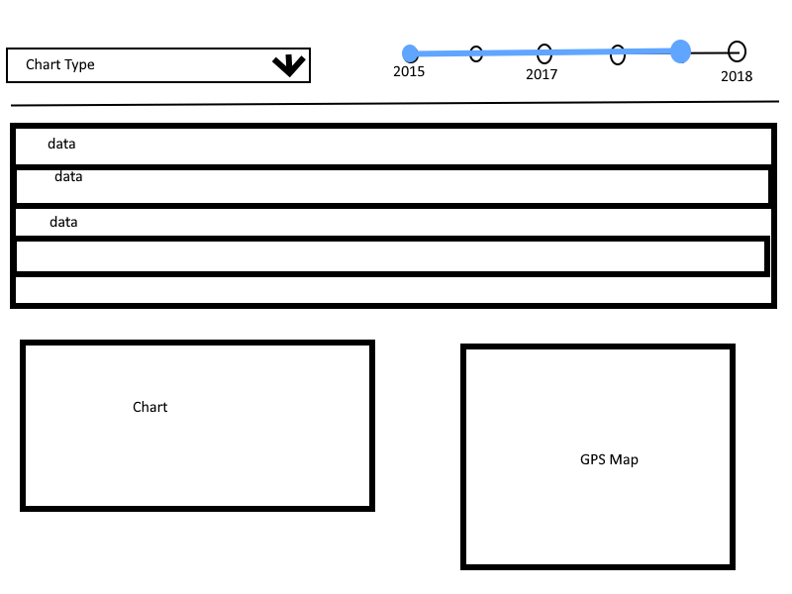
Here you can see the addition of some new options,
In the top right I have now a time period selector, this is to adjust your graphs data based on the years of the data input.
On the top left I have added a drop down, this is to change the type of graph you have selected. Which in this case will allow us to include some new categories from the CSV file.
After going through some python bugs, I was able to resolve by adjusting the port from 8050 to 8051, as I have another application running on the other port.
Additionally, I did run into some difficulties with depreciated plotly libraries being used, but ultimately after researching on OWASP I was able to identify that while depreciated, this is the most secure version for the tools I am using from the library.
Here is the new UI with running the all in one file,
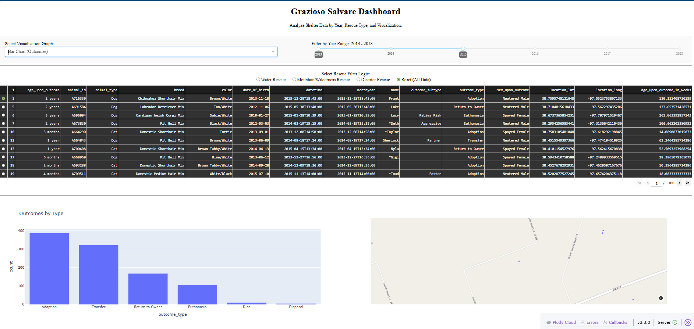
The updated dashboard allows for varying perspectives, which will allow a diverse audience to give opinions on the animal shelter data. The new all in one design allows it to be run independently from MongoDB while still giving the ability to use the this layout on a MongoDB server, which can give some users the ability to run offline.
My experience in large scale databases like this is from the county of Los Angeles, I work for the Agricultural commissioners/ Department of Weights and Measures. We use an in house design app called Cal traps. This was made using GIS tools and python. The biggest convenience we gave ourselves was a pocket version of the app. The ability for Inspectors to pull up where they put traps in fruit trees on a map when they are without cell service gave our app extreme utility. This app having a portable version will give the same effect to those needing to view it offline.
The algorithmic principles are all within the visualization, using a multi layered conditional query to locate and update the plotly shapes. By choosing to implement the solution using Pandas Dataframes I have balanced the trade off between speed and complexity. Pandas library is highly optimized for fast filtering and data manipulation. Which is why my dashboard feeling interactive, despite the thousands of records it sorts through. Which is why it’s a great start for a prototype of a potential large-scale app with much more data.
I used modern tools between Python, Pandas, and Dash. The entire application demonstrates the model view controller patter through Dashs call back structure. The inputters act (the dropdown for changing the graphics, and the slider for changing the time periods.) acts as the controllers, the dataFrame filtering is the model and the table graphics are the view.
This updated version of my MongoDB and Python app, has changed some options for usability and can now be run on a larger variety of devices which may lack the ability to run a whole MongoDB server. Additionally, the tools I added with different graphs, and time frame customization now give the app even more usability for a larger variety of functions.

